

Introduction to deep learning

Midterm project report

YOLO for Medical Image Segmentation- Case study: Lung cancer

Group 9’s members:

|  |  |
| --- | --- |
| Vũ Đức Duy | 22BI13127 |
| Nguyễn Hoài Anh | 22BI13021 |
| Nguyễn Việt Anh | 22BI13032 |
| Phạm Hoàng Anh | 22BI13034 |
| Lâm Chí Cường | 22BI13068 |
| Nguyễn Át | 22BI13047 |

Contents

I. Introduction 2

# Introduction

You only look once (YOLO) is a real-time object detection model which is widely used in computer vision tasks and known for its speed and accuracy in detecting objects within the images and videos. You Only Look Once (YOLO) proposes using an end-to-end neural network that makes predictions of bounding boxes and class probabilities all at once. It differs from the approach taken by previous object detection algorithms, which repurposed classifiers to perform detection.

The evolution of YOLO verison:

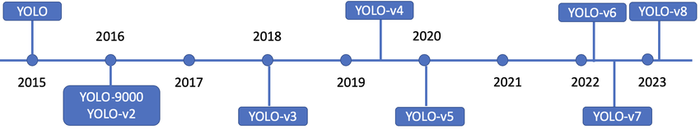

In this project, we use YOLO-v8 for Medical Image Segmentation – Case study: Lung cancer. Currently, lung cancer is one of the diseases causing the highest mortality rate worldwide. With the development of AI and deep learning technologies, YOLO have become critical tools in medical imaging so that the Medicine can give the patients early detection and precise diagonosis. This report focuses on the application of YOLOv8, the latest version of the YOLO family, for lung cancer image segmentation. We specifically investigate how well it can detect lung cancer nodules in medical images, comparing it to YOLOv5, a commonly used model in previous studies on lung nodule detection.

The evaluation is based on segmentation accuracy, computational efficiency, and overall performance. YOLOv8, with its upgraded design and added functionalities like better model scaling and quicker inference times, offers more accurate segmentation outcomes. YOLOv5, however, is known for its dependability and widespread use in medical settings, especially for identifying lung nodules.

Our report seeks to offer insights into the effectiveness, benefits, and possible constraints of implementing YOLOv8 and YOLOv5 in lung cancer image analysis through a comprehensive case study, emphasizing their contributions to improving early detection and treatment plans.